

**NAME: DOROTHY ARABA YAKOBA AGYAPONG (MRS.)  
STUDENT ID: 201314090102**

**SCHOOL: SCHOOL OF LIFE SCIENCES**

**COURSE: DIGITAL SIGNAL PROCESSING**

**QUESTION 2:**

WHY THE FREQUENCY SPECTRUM IS MEANINGFUL, TALK ABOUT SOME ENGINEERING APPLICATIONS OF SIGNAL SPECTRUM.

**30TH NOVEMBER, 2013**

**ABSTRACT**

Frequency spectrum is one of the oldest and most useful technologies to human existence. The frequency spectrum of a signal consists of the plots of the amplitudes and phases of the harmonics versus frequency. It is a representation of basically all existing signals and knowing the exact frequency of a signal can go a long way to aid in making the life of a human or any other organism easier. This is a report on the frequency spectrum and how it is generated as well as some of the many engineering applications of the frequency spectrum which includes, radar, television, internet, mobile telephony, to mention a few.

**INTRODUCTION**

The energy created by electromagnetic radiation is generated from the forces exerted by the variable fluctuations of magnetic and electrical force fields emanating at right angles to each other travelling at the speed of light. These electromagnetic disturbances create waves which can be measured and which occur or pulse at different rates or frequencies each second. A *frequency spectrum,* is a method of classifying the discrete and unique elements of all electromagnetic occurrences in terms of the frequency of the radiated energy induced each second. Radio waves, television broadcasts, X-rays, microwaves, and infrared transmissions are all electromagnetic radiations whose essential attributes can be defined and identified by the frequency or amount of radiation each type produces.

Frequency is defined as the number of complete electromagnetic energy wave cycles that occur each second. The international unit of measurement used to describe one cycle is 1 hertz (Hz). Since each portion of the electromagnetic spectrum has a telltale frequency signature, it can be identified by means of a frequency spectrum analyzer that is capable of accurately measuring the wave cycles per second of the particular electromagnetic phenomenon under observation.

Frequency spectrum of a time domain signal is the frequency domain representation of that signal. This can be achieved through the use of a Fourier transform for the signal, and the resulting values are usually presented as amplitude and phase with both plotted against frequency (Sadiku, 2012). Any signal that can be represented as an amplitude that varies with time has a corresponding frequency spectrum. This includes phenomena or familiar concepts such as visible light (colour), sound, radio/television channels and even the rotation of the earth to mention a few. When these physical phenomena are represented in the form of a frequency spectrum, certain physical descriptions of their internal processes become much simpler.

Each of the varied forms of electromagnetic energy occupies a designated place on the frequency spectrum. The electromagnetic continuum, as expressed in terms of the frequency or the intensity of radiation emitted by each distinct segment, ranges from 106 Hz up to 1025 Hz. Radio waves occupy the low end of the frequency spectrum whereas radioactive gamma rays occupy the high end. The frequency range encompassed by the electromagnetic spectrum is immense. Frequencies generated by radio transmissions and those produced by visible light vary by an order of magnitude of a million /billion.

The frequency spectrum for radio transmission is further classified into ranges of frequencies or "bands," both as a means for minimizing interference as well as for sharing bandwidth among multiple users. The International Telecommunications Union (ITU) Agreement allocates certain ranges of radio transmission frequencies so as to minimize interference in the shortwave radio spectrum. The high frequency bands are allocated among international shortwave broadcasters, amateur radio operators, and marine radio communications. In order to insure reliable, interference-free radio transmissions, domestic governmental agencies often regulate certain aspects of the frequency spectrum. In the United States, the Federal Communications Commission (FCC) allocates the frequency bands between businesses, the general public, and amateur radio operators so as to limit any potential cross-band interference. Each band is designated a specific frequency range, and that frequency spectrum is reserved for each of the various user-specific groups.

Often, the frequency spectrum clearly shows harmonics, visible as distinct spikes or lines at particular frequencies, that provide insight into the mechanisms that generate the entire signal. Representing signals with frequency spectra shows harmonics which are visible as distinct spikes or lines that provide insight into the mechanisms that generate the entire signal. This makes certain physical descriptions of their internal processes much simpler. The diagram below shows the full frequency spectrum and below it is a brief discussion about some of its applications.

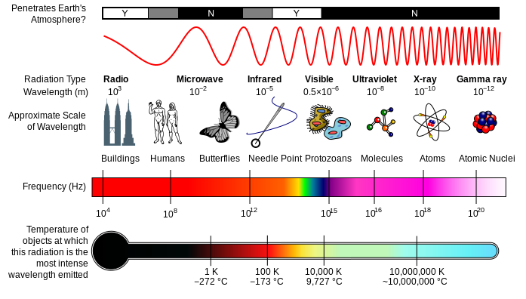

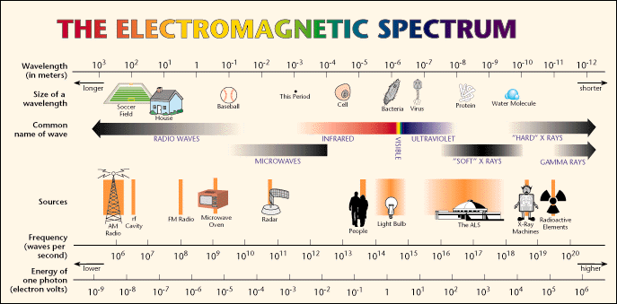

Figures 1-2: Electromagnetic Spectrum (Source: <http://chemwiki.ucdavis.edu>)

**THE ESSENCE OF THE FREQUENCY SPECTRUM**

It is worth noting that, all communications take place using at least one part of the spectrum shown above and hence it is prudent to say the frequency spectrum is the most important ingredient to any form of communication, be it physical or electronic.

The spectrum is very important to human life because, different frequencies have different uses and dangers and hence knowing the spectrum and its applications can save life as well as giving one a better life. To make use of the spectrum for any engineering work, one must consult the organization responsible for allocation of frequencies within the country he/she is, for authorization before they start work. This is not the case for all frequencies though since some frequencies are free to use and hence do not require any authorization. The organization responsible for allocation of frequency bands all over the world is known as the International Telecommunications Union(ITU) and every country has a representative group associated with ITU. The spectrum aids engineers in avoiding Electromagnetic interference which is the degradation in the performance of an equipment caused by an electromagnetic disturbance. The spectrum helps avoid this by aiding engineers know which frequencies they are working in and hence enables them to avoid bringing in equipments which work in the same frequencies or frequencies that will interfere with the frequencies they are already working with.

**ENGINEERING APPLICATIONS OF SIGNAL SPECTRUM**

Electromagnetic radiation is the means for many of our interactions with the world such as: light allows us to see; radio waves give us TV and radio; microwaves are used in radar communications; X-rays allow glimpses of our internal organs; and gamma rays let us eavesdrop on exploding stars thousands of light-years away. Electromagnetic radiation is the messenger, or the signal from sender to receiver. The sender could be a TV station, a star, or the burner on a stove. The receiver could be a TV set, an eye, or an X-ray film. In each case, the sender gives off or reflects some kind of electromagnetic radiation.

Broadcasting communication is the distribution of audio and video content to a dispersed audience through any visual or mass communication medium which is usually via the use of electromagnetic radiations. Broadcasting is one of the most common applications of the frequency spectrum as is seen in the widespread usage of television, radio and even the world wide web(www). Broadcasting is mostly achieved through the use of the radio waves which is part of the spectrum, which spans from about 3KHz to 300GHz. Broadcasting started off by using just analogue signals as is the case in almost all technological innovations. Recently though, most broadcasters are migrating into the digital world.

Ghana among other countries are now migrating from analogue to digital TV broadcasting to comply with the GE-06 Agreement to meet the 2015 deadline set by the International Telecommunication Union (ITU). This migration is the largest initiative to impact the Ghana TV broadcasting since the conversion from black and white to colour TV in the 1980’s (Digital Migration report, 2011).

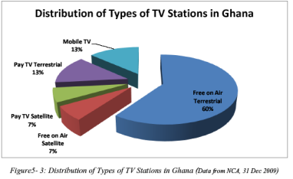

This migration to the digital world is due to its many advantages some of which are elaborated in this report .

*Spectrum Efficiency*: The use of analogue signals, means each broadcast programme channel (television station) is assigned a single frequency channel and also, adjacent channels could not be used due to adjacent channel interference effects. These two challenges are not desirable mainly due to spectrum overcrowding.

Spectrum overcrowding as its name implies, simply means too many technologies competing for little spectrum. Digital signals solves this problem using one of its most desirable properties; the ability to be compressed. This is achieved through the use of standards like the MPEG 3(mp3), MPEG 4(mp4), etc. Due to the ability to be compressed, using digital signals for broadcasting makes it possible for more programmes to be fitted into the same frequency channel as is seen below.



Figure 2: Spectrum Efficiency of Digital Broadcasting

Also, with digitization, adjacent channels can be used without adjacent interference mainly because the access techniques used for multiplexing digital signals have re-use distances of one and hence, the same frequency can be used for adjacent channels. Doing this frees up the frequency spectrum for upcoming technologies such as Mobile broadband.

Digital broadcasting also promises such features as better picture quality and quality CD sound, due to the fact that they are in a way immune to noise. That is, if a digital signal is affected by noise as it travels through the channel, the noise can be entirely taken away and the original signal recovered perfectly at the receiver's end. This cannot be achieved in the analogue world. A practical illustration of this property is shown below.



Figure 3: Enhanced picture quality of Digital Broadcasting

Also, Digital broadcasting serves to grant the consumers more stations to choose from, as well as offer them more interactivity as is seen in the use of Electronic Programming Guides(EPG) which shows the consumer the upcoming programmes of a station, games, and a whole lot of other rich applications.

Frequency is inversely proportional to wavelength and signals with longer wavelengths have the tendency to travel far whiles those with short wavelengths are easily absorbed by objects they come into contact with. Even though long wavelength signals have the ability to travel far, they are rarely used due to the fact that wavelength is directly proportional to antenna size and hence using such signals will mean designing antennas with impractical sizes or ones that require very large piece of land which is undesirable. Also, larger frequencies offer larger bandwidth for communication channels and hence very low frequency signals are mostly not suitable for applications that require a high transmission rate. A typical example is the use of Extremely Low Frequency signals (ELF) which has wavelengths of 106 meters or more, for submarine communications. Generally, the ELF signal serves to request that a submarine surface is present and initiate some other form of contact. The United States has two sites in Wisconsin and Michigan for the international transmission of their ELF submarine signals. Both sites use long power lines as antennae in multiple strands ranging from 14 to 28 miles long. As can be predicted, considerable amounts of power are generated and emitted by such a system and thus concerns over the ecological impact have been raised.

Another very important application of the frequency spectrum can be found in the 30PHz-60PHz range, where we have the X-rays. These signals have very short wavelengths and thus do not travel far but can penetrate easily through objects. This type of signal is widely used in the medical domain for detecting broken bones.

Most X-rays have a wavelength in the range of 0.01 to 10 nanometers, corresponding to frequencies in the range of 30 petahertz to 30 exahertz (3×1016 Hz to 3×1019 Hz) and energies in the range 100 eV to 100 keV. However, much higher-energy X-rays can be generated for medical and industrial uses, for example radiotherapy, which utilizes linear accelerators to generate X-rays in the ranges of 6-20 MeV. X-ray wavelengths are shorter than those of UV rays and typically longer than those of gamma rays. X-rays are basically the same as visible light rays. Both are wavelike forms of electromagnetic energy carried by particles called photons. The difference between X-rays and visible light rays is the energy level of the individual photons. This is also expressed as the wavelength of the rays. Radiography has applications in both medicine and industry, where it is valuable for diagnosis and non destructive testing of products for defects.

X-ray imaging creates pictures of the inside of your body. The images show the parts of your body in different shades of black and white. This is because different tissues absorb different amounts of radiation. Calcium in bones absorbs x-rays the most, so bones look white. Fat and other soft tissues absorb less, and look gray. Air absorbs the least, so lungs look black.

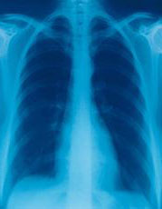

Fig. 4 A typical chest x-ray

The most familiar use of x-rays is for checking broken bones, chest x-rays can also be used to diagnose pneumonia. Mammograms also use x-rays to diagnose and treat breast cancer.

Another use of radiography is in the examination and analysis of paintings, where studies can reveal such details as the age of a painting and underlying brushstroke techniques that help to identify or verify the artist. X rays are used in several techniques that can provide enlarged images of the structure of opaque objects. These techniques, collectively referred to as X-ray microscopy or micro radiography, can also be used in the quantitative analysis of many materials. One of the dangers in the use of X rays is that they can destroy living tissue and can cause severe skin burns on human flesh exposed for too long a time. This destructive power can however be used in X-ray therapy to destroy diseased cells.

**CONCLUSION**

Frequency spectrum is one of the most helpful innovations in the engineering world since almost all engineering fields make use of this spectrum in one way or the other. This report elaborated on some of the communication based applications of the spectrum with emphasis mostly on broadcasting. It was realised that broadcasting is mainly done in the radio waves part of the spectrum and also the use of digital signals for broadcasting is much more desirable and more advantageous than the use of analogue signals. Medical application of the spectrum was also discussed briefly by the use of X-rays. There are however, many other applications of the spectrum including satellite communications, radar, sonar, etc which are not reported on.

**REFERENCES**

1. V. Prasad Kodali: "Engineering Electromagnetic Compatibility: Principles, measurements and technologies". "IEEE electromagnetic society, sponsor", 1996. ISBN 0-7803-1117-5.
2. Report: Report to the government of Ghana on the migration from analogue to digital broadcasting

in Ghana, National Digital Broadcasting Migration Technical Committee, August 2010

1. <http://nca.org.gh/documents/digital_broadcasting/digital_migration_report_30_Aug_2010.pdf> (accessed November 22, 2013)
2. Alexander Charles; Sadiku Matthew (2012). "Fundamentals of Electric Circuits" (Fifth ed.). McGraw-Hill. p. 761. ISBN 978-0-07-338057-5.
3. Prof. Jing-Ran Lin, University of Electronic Science and Technology, China: Digital Signal Processing Lecture notes.
4. <http://chemwiki.ucdavis.edu/Physical_Chemistry/Spectroscopy/Fundamentals/Electromagnetic_Radiation> [accessed 2013, November 21st]
5. [http://www.infoplease.com/encyclopedia/science/x-ray-applications-x-rays.html#ixzz2lIeJh8DR](http://www.infoplease.com/encyclopedia/science/x-ray-applications-x-rays.html%23ixzz2lIeJh8DR) [accessed 2013, November 24th]